Program:

app.py:

from flask import Flask.render_template

app=Flask(_ _name_ _)

@app.route('/home')

def homepage():

    return render_template('home.html')

@app.route("/about")

def aboutpage():

    return runder_template('about.html')

@app.route("/signin")

def signinpage():

    return render_template('signin.html')

@app.route("/signup")

def signuppage():

    return render_template('signup.html')

if _  _name_ _=="_ _main_ _":

    app.run(debug=True)

home.html:

<!DOCTYPE html>

<html>

    <head>

        <style>

            p{

                font-size: bold;

            }

        </style>

    </head>

    <body>

        <a href="/">HOME</a>

        <a href="about.html">ABOUT</a>

        <a href="signup.html">SIGNUP</a>

        <a href="signin.html">SIGNIN</a>

        <br><br>

        <p>Welcome to My page</p>

    </body>

</html>

about.html:

<!DOCTYPE html>

<html>

    <head>

        <title>Web Page</title>

    </head>

    <body>

        <h1>This is a Web Page</h1>

        <p>Hello, form about Page</p>

    </body>

</html>

signup.html:

<form action="/signup" method="POST">

    <label>Name</label><br>

    <input type="text" name="name"><br><br>

    <label>Email</label><br>

    <input type="email" name="email"><br><br>

    <label>Phone</label><br>

    <input type="text" name="phone"><br><br>

    <label>Password</label><br>

    <input type="password" name="name"><br><br>

    <label>retype password</label><br>

    <input type="password" name="name"><br><br><br>

    <input type="submit">

</form>

signin.html:

<h1>Signin Page</h1>

<form action="/signin" method="POST">

    <label>Email</label><br>

    <input type="email" name="email"><br><br>

    <label>Password</label><br>

    <input type="password" name="name"><br><br>

    <button>Signin</button>

</form>

OUTPUT:

Home page

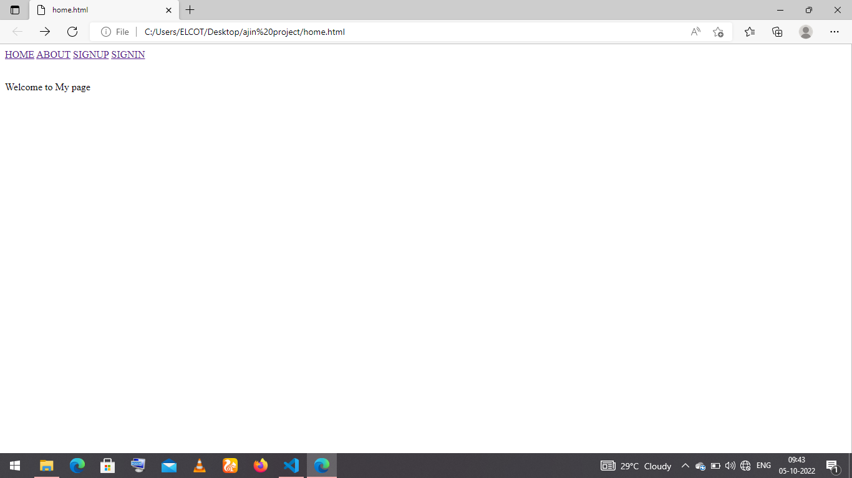

About page

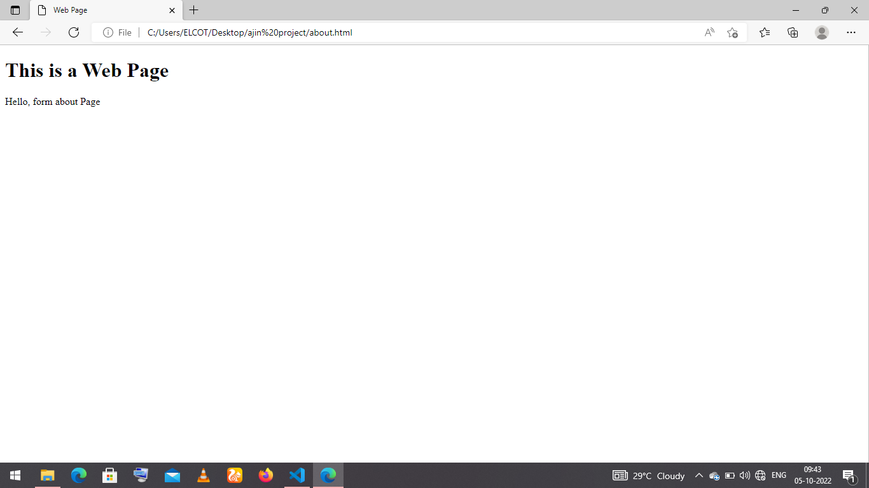

Signup page

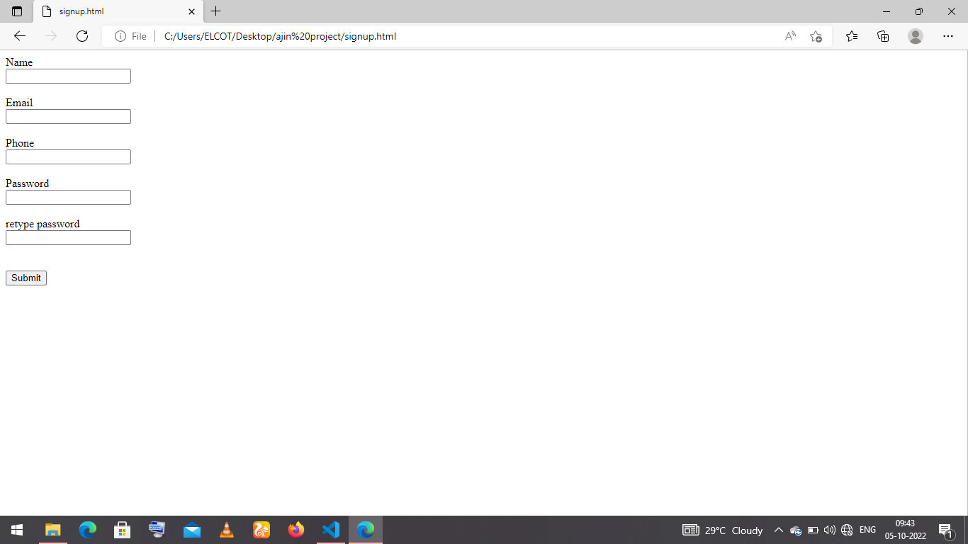

Signin page

